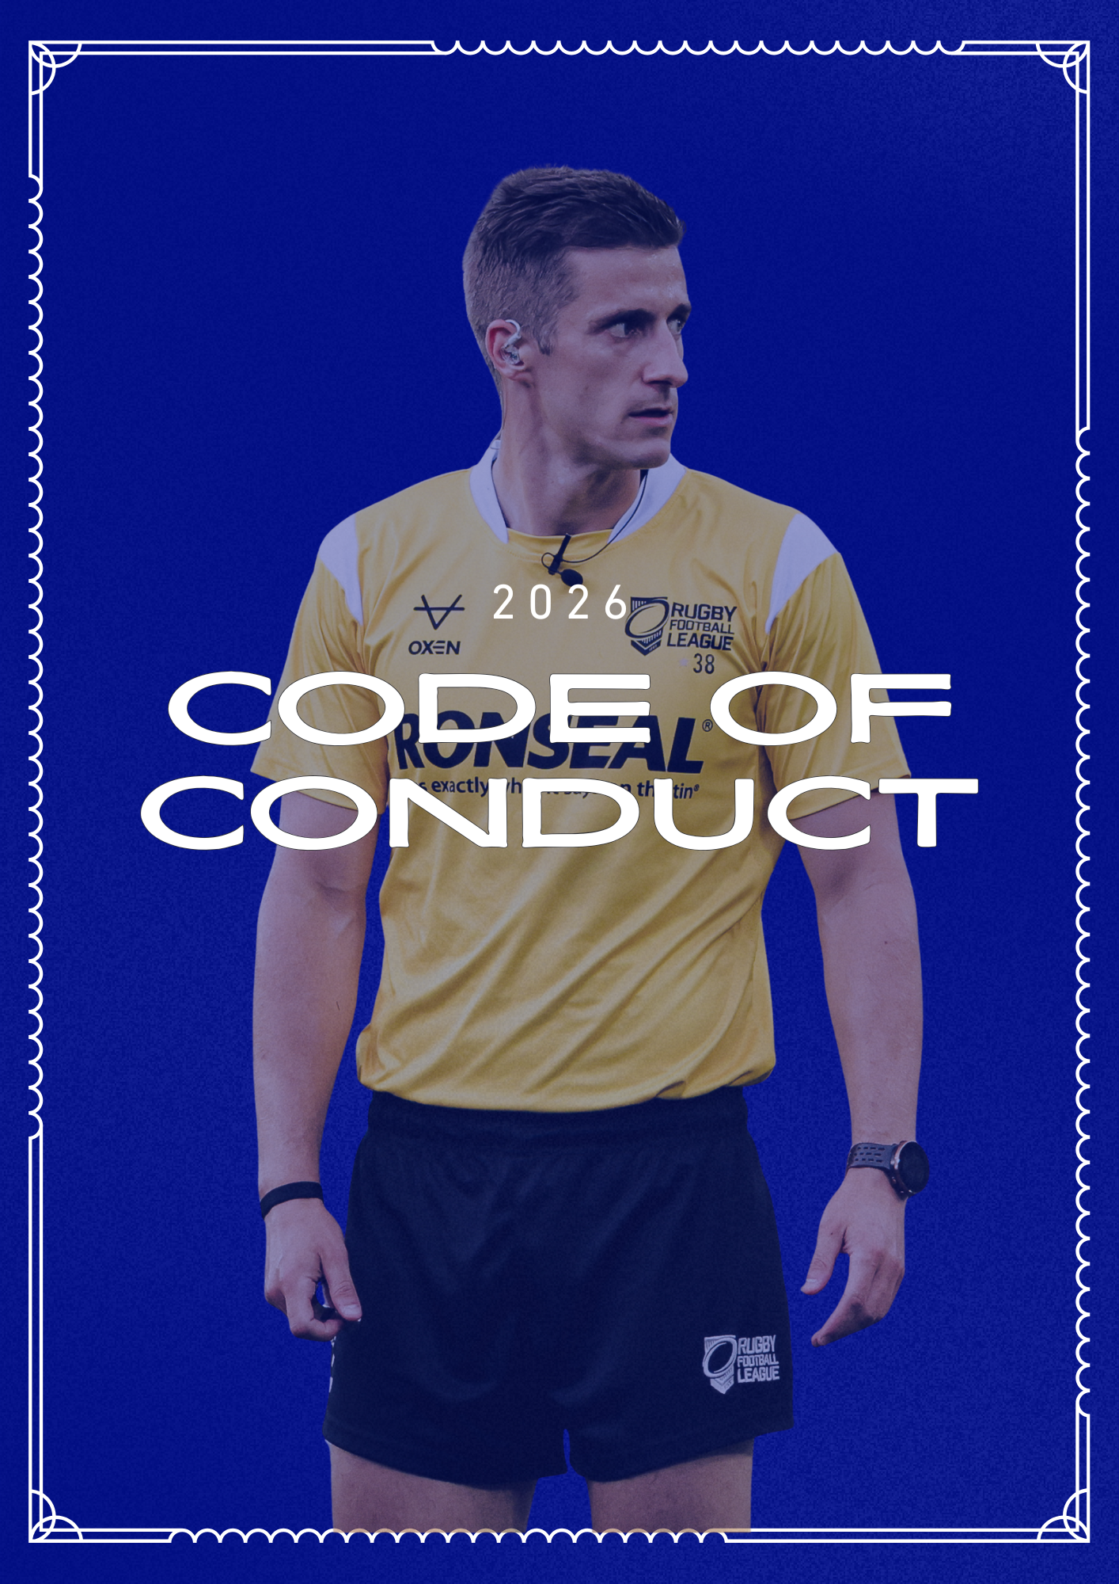

Match Officials Code of Conduct 2026
The RFL is committed to equality through diversity and as such treats all [players, coaches, spectators, volunteers, and officials] the same regardless of age, sex, race, disability, pregnancy, marital/ civil partnership status, sexual orientation, gender reassignment or religious background.
Public Confidence
1. No Match Official shall:
1.1 Engage in any conduct that might impair public confidence in the honesty or integrity of themselves;
1.2 Engage in any conduct that is detrimental to; bring into disrepute; act in a manner inconsistent with; act in a manner contrary to; or act in a manner prejudicial to the best interests, image or welfare of the game of Rugby League;
1.3 Engage in any conduct that might impair confidence in the integrity of the game of Rugby League; or
1.4 Engage in any conduct that might impair public confidence in the honesty or integrity of other Match Officials, RFL & Club Officials, Players and Coaches; Whether in public, at a Rugby League event, match or when making public postings and/or messaging on fans forums and social network sites (including but not limited to Facebook and Twitter).
Social Network & Forums
2. Whenever using social media, digital media, blogs, email, websites, fans forums or any other form of communication network, Match Officials shall:
2.1 Use them sensibly, professionally, lawfully, courteously and consistently with their duties.
2.2 Respect their colleagues and other participants of the sport including but not limited to coaches, players, management, RFL employees, club officials, directors and supporters and the RFL generally.
2.3 Not make adverse comments on matches, other official’s performances, decisions, or incidents that occur during a game.
2.4 Not criticise any player, coach or official of a club, the RFL or a colleague or fellow match official.
2.5 Ensure that any posting on their wall or media network are properly policed and ensure that any critical comments are deleted immediately upon being seen by the Match Official.
2.6 Not use offensive language or post offensive photographs.
2.7 Ensure that no photographs appear on the relevant network that may compromise the integrity of the Match Official, cause the RFL or the Match Official in question to be in a position of professional embarrassment or may undermine the public’s perception of the integrity of the Match Official.
2.8 Ensure that no photographs are published that are in breach of this Code of Conduct.
2.9 Ensure that at all times the public’s perception of the individual Match Official or match officials generally is not undermined, questioned or brought in to disrepute and that no postings are in breach of any section of this Code of Conduct. For the avoidance of doubt, Match Officials will be responsible for the content of any message that is liked, shared or retweeted. Conduct Related to Matches & Training.
3. Match Officials shall:
3.1 Prepare fully both physically and psychologically for a match. On a physical level a Match Official must be able to keep up with the speed of the modern game and be alert and close enough to take correct decisions from credible locations on the field of play;
3.2 Apply the Laws of the Game with complete impartiality irrespective of the teams, players or team officials involved in the match;
3.3 Ensure they have an up to date working knowledge of current guidelines for both on and off field policy.
3.4 Resist any possible influence from protests on the part of players, team officials or spectators;
3.5 Not tolerate inappropriate language from players and/or officials;
3.6 Not use their mobile phone or any form of wireless device capable of sending or receiving data, video footage or voice recording in any way from 90 minutes prior to kick off or upon receipt of a team sheet (whichever is received first) until the conclusion of the match. Should an emergency occur then a Match Official may use their mobile phone but only after confirming the reason for doing so with the Match Commissioner or another senior official in his absence.
Drugs and Alcohol
4. Match Officials acknowledge that use of recreational drugs and excessive alcohol consumption may impact their performance and agree to take part in education and training on such matters as reasonably directed by the RFL.
5. Match Officials shall conduct himself/herself at all times in public in a sober, courteous and professional manner.
Harassment and Criticism of Match Officials
6. No Match Official shall:
6.1 Publish or cause to be published (or give any interview to the media by whatsoever medium) which contains unreasonable criticism of the manner in which a Match Official has controlled a Match. For the avoidance of doubt Match Officials can comment on matters of fact during a Match (including referees’ decisions) but cannot question the character, integrity and competence of the Match Officials.
6.2 Harass any other Match Official about decisions, their performance or any other aspect of their role. For the avoidance of doubt nothing in this clause shall prevent a Match Official criticising another Match Official’s decision at a Match Officials’ meeting, training session or through their appropriate manager.

Commercial Partners and Media
7 Match Officials shall co-operate with the RFL, the media and its commercial partners as reasonably requested by the RFL.
8 Match Officials shall not give interviews about matches, decisions made by themselves or other match officials or rugby league generally to any member of the media without having first obtained permission from the Head of Match Officials.
Players and Officials Dress
9 Every Match Official shall ensure that he is properly attired and, where appropriate, dressed in the apparel required by the Head of Match Officials in all public appearances as a Match Official.
10 Every Match Official agrees that upon request from the RFL he will remove or cover up any item of clothing, body garment, tattoo or other such product howsoever showing that is advertising a product, service or company that is engaged in the same business sector as a partner of the RFL or one of its conducts.
11 When appointed to a match by the RFL, each Match Official will wear the kit provided by the RFL kit supplier. Further, each Match Official shall ensure that if an item of clothing is worn that is not produced by the RFL kit supplier then any logos or marks that are visible are covered up.
Unlawful Conduct
12 No Match Official shall engage in any conduct that is against the law of the place where the conduct occurs.
Inducements
13 No Match Official shall offer or receive a bonus or any form of inducement whether directly or indirectly and by whatever means to alter or influence their decision in a Match.
Betting
14 No Match Official shall place, accept or lay a bet on any Match or in relation to Rugby League in any way or provide information or do any other act or thing which is calculated to or does assist others involved in any of the foregoing.
Discrimination
15 No Match Official shall engage in discrimination on the grounds of age, ethnic origin, race, gender, special needs including learning and physical disabilities, class or social background, religion, sexual orientation, marital status, pregnancy, colour or political persuasion (any such conduct which is referred to as “Discriminatory Behaviour”).
Gestures to Spectators
16 No Match Official shall make any gesture to the crowds that may be considered obscene or alternatively which may be considered likely to incite the crowd to disorder.
Language
17 No Match Official shall subject any spectator, member of the public, staff at hotels, ground staff or other person to foul and/or abusive language.
Unruly Behaviour
18 No Match Official shall behave in an unruly manner in any public place which for the avoidance of doubt shall include but not be limited to bars, hotels, airports, flights to and from RFL matches, the tunnel and dressing room areas.
Conduct Prejudicial to the Interests of Rugby League
19 No Match Official shall behave in a manner which is prejudicial to the nterests of Rugby League or which may cause hurt, annoyance or injury to the sport of Rugby League.
Safety
20 No Match Official shall fail to comply with any reasonable instruction of the Ground Safety Officer, Police Commander, Head of Match Officials, or their lawful representative at any venue.
Travel to Matches & Training
21 All Match Officials should, where possible, travel to and from matches together in the referee’s car. Any queries in this regard should be addressed with the appropriate manager prior to acceptance of the match.
22 No Match Official may claim travel expenses for a match that they travelled independently to unless they had received written authorisation from their appropriate manager.
23 Match Officials should, where possible, travel together to and from training sessions.
24 All Match Official expense claims will be subject to approval by the RFL Match Officials Administrator and/or RFL Match Officials Operations Manager who shall have the power to query any claim prior to authorisation.
Attendance at RFL Events & Matches
25 All Match Officials
25.1 Are personally responsible for any guests that they obtain tickets to matches for.
25.2 Will comply with the Pass Holder Information documents issued from time to time.
25.3 Will act in a sober and courteous manner at matches.
25.4 Not be seen at matches wearing club apparel, engaging in chants or compromising their integrity and their ability to officiate.
25.5 Will conduct themselves with the utmost integrity and professionalism.
General
26 Match Officials will:
26.1 Avoid doing anything that may give rise to a conflict of interest and if a conflict arises then the Match Official shall immediately inform their appropriate Manager of the situation and seek advice.
26.2 Complete all relevant forms and documents as requested.
26.3 Keep the Match Officials Department updated regarding fitness, injuries, health, wellbeing, mental state and availability.
26.4 Comply with requests from the Match Officials Department regarding the use of any materials forwarded and ensure they are treated confidentially at all times, including but not limited to Match Official Appointments.
26.5 Comply with the RFL Operational Rules
26.6 Comply with the RFL Safeguarding Policy
26.7 Claim their fees on a monthly basis, or in exceptional circumstances only with preference of manager, within 3 months of the game officiated. Understands that, If deadline not met, could result in fee(s) not being paid.
26.8 Will attend all society meetings where available.
Misconduct under the Code of Conduct
27 All Match Officials acknowledge that their behaviour shall at all times be of the highest standard.
28 A Match Official may be guilty of misconduct if he/she:
28.1 Commits a breach of this Code of Conduct.
28.2 Commits a breach of the RFL Operational Rules.
28.3 Commits a breach of the RFL Safeguarding Policy.
28.4 Engages in conduct which is prejudicial to the interests of the game of Rugby League.
28.5 Is convicted of a criminal offence by any court of competent jurisdiction other than an offence under any road traffic legislation for which a fine or non-custodial penalty is imposed.
28.6 Fails, within the time specified, to comply with any decision of the RFL, Head of Match Officials, the Compliance Manager or an Operational Rules Tribunal.
Proceedings for Breach
29 Where any Match Official has failed to comply with a provision of this Code of Conduct, proceedings may be taken against that Match Official for that failure, and a penalty imposed.
Allegations of Misconduct
30 If any person reasonably believes that any Match Official is guilty of misconduct he or she must immediately inform the Head of Match Officials in writing setting out all the relevant details of the alleged misconduct. The Head of Match Officials shall have the power to investigate such allegations and, if he/she believes there is a case to answer, refer such allegations to the RFL Compliance Manager who in turn may investigate the matter and if required refer the matter to the RFL Operational Rules Tribunal in accordance with the RFL Operational Rules.
I confirm that I have read the Match Officials Code of Conduct and agree to be bound by the terms of the document for the duration of 2026 Season.

